Title: A Guide to Studying Abroad in Paris
Topic: Wildcard
Author: Mia Serrano-Salow
Cover Photo:
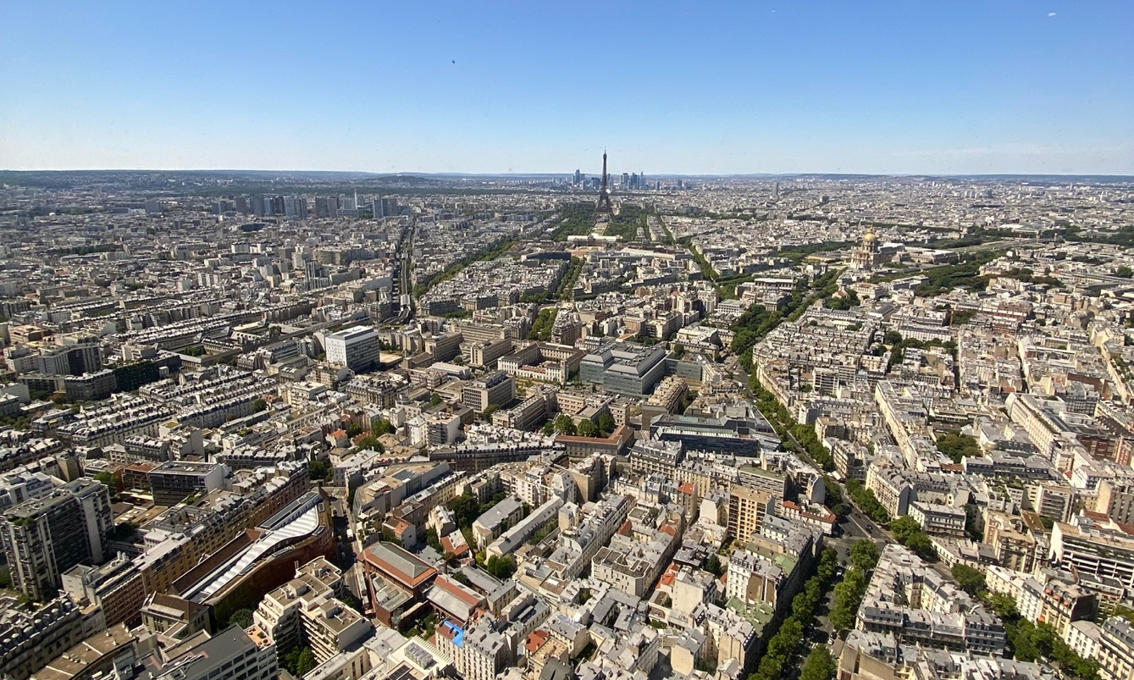
Image Courtesy: Mia Serrano-Salow
The summer of 2022 was the best summer of my life. More specifically, July of 2022 was the best month of my life. I spent one whole month strolling along the Seine, eating fresh croissants every morning, and observing world-famous art like da Vinci’s Mona Lisa and Monet’s Waterlilies. Although this sounds like a vacation, I was in Paris to study through FSU’s International Programs. Talking about this experience has become one of my hobbies now, so what better way to spread the word than to publish it? I have compiled a mini guide to making your way around Paris as a student based on my experience. I hope this guide has some recommendations that you’ll mark on your map. (Below is me seeing the Eiffel Tower for the first time ever!)
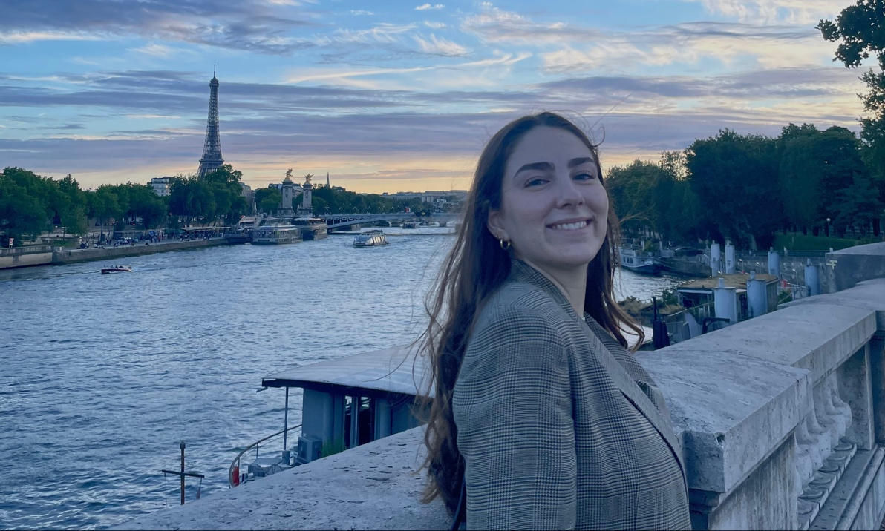
Image Courtesy: Cecilia Salow
First and foremost, I went to Paris to improve my French and to take classes for my French language minor. Through FSU’s International Programs, myself and 14 other FSU students took classes at the Catholic University of Paris. Although we only took two courses, our week was jam-packed. We had class every day from 9 am to 12 pm, a 2-hour lunch break, and then on Tuesdays and Thursdays again from 2 pm to 5 pm. When we weren’t in class, we took excursions, ate at renowned restaurants, and took day trips as a group with our director, Dr. Vincent Joos. Dr. Joos, a France native, made our experience so much more special because of his knowledge of the city. On our first day of the program, he led us on a quick metro trip to a beautiful farmer’s market where locals sold produce, prepared street food, handmade items, books, and more. There are farmer’s markets all over Paris, so I highly recommend visiting one for a more local experience. I also had the best lavender ice cream I’ve ever had in my life there, which I recommend trying if you’re in Paris during the hot summer months.
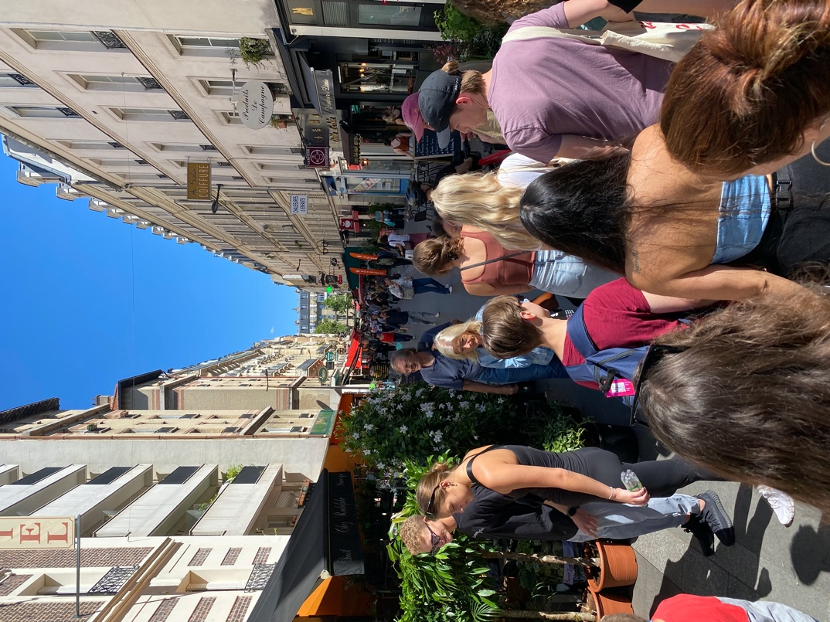
Image Courtesy: Mia Serrano-Salow
I can confidently say that I had the best food of my life in Paris. I thought the next meal couldn’t get better than the last, but it did. I also tried some foods I had never had before, like soufflé. For the best soufflé in Paris, make a reservation at Le Soufflé. It was so difficult to pick my favorite meal I had in Paris, so there had to be a tie. Right by the Seine and the Musée d’Orsay, the restaurant Les Antiquaires serves amazing French cuisine. I had the magret de canard, or duck breast, served with potatoes and a sautéed pear slice. The meal that tied with this one was the best burger I’ve ever had in my life. It was from Dinand, a sister location to the celebrity-loved restaurant Ferdi. I also had to make a few stops at Ferdi to see what the hype was all about, which I now understand.
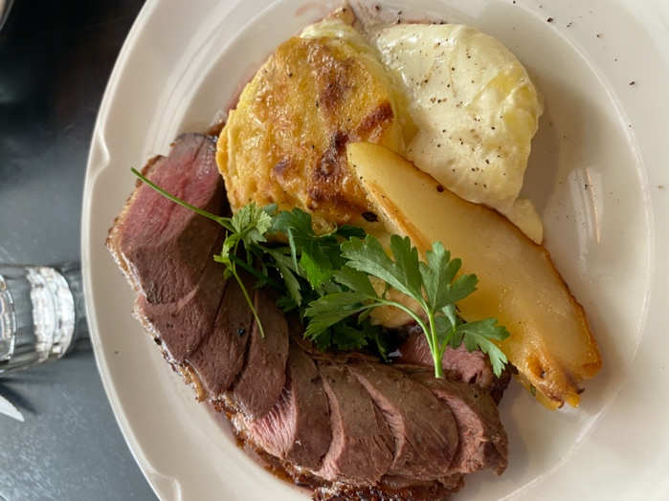
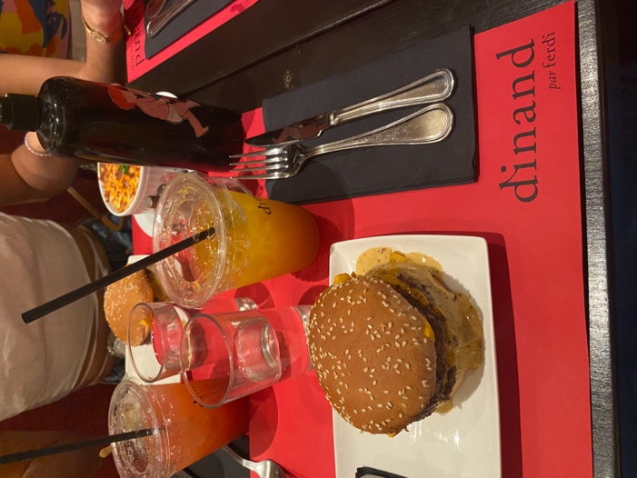

Image Courtesy: Mia Serrano-Salow
There are too many memories to squeeze into this post, but I need to include our group day trip to Claude Monet’s house in Giverny. Just a one-hour bus ride away, this is a must-see experience. The bright pink and green house flooded by miles of flower gardens was home to Claude Monet and the place that inspired his most famous work, the Waterlilies.
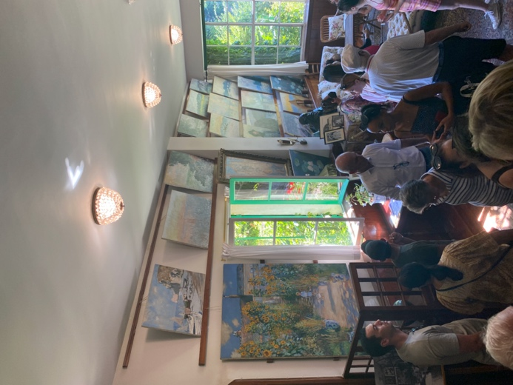
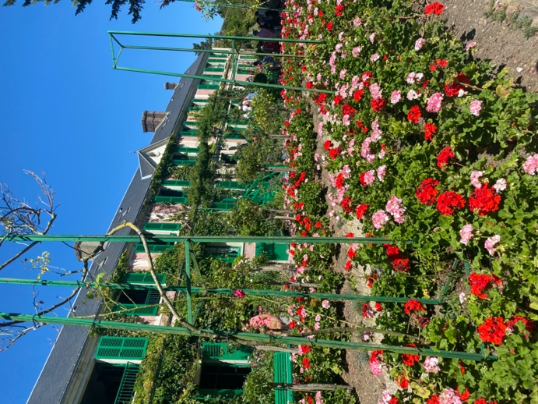

Image Courtesy: Mia Serrano-Salow
If you are thinking about studying abroad, this is your sign to do it. Signing up for this program has changed my life for the better. I have met some of my best friends for life and the memories I created with them in Paris are ones that I will never forget. I am counting down the days until I can go back to Paris and revisit all these places, and to explore all the things I have yet to.
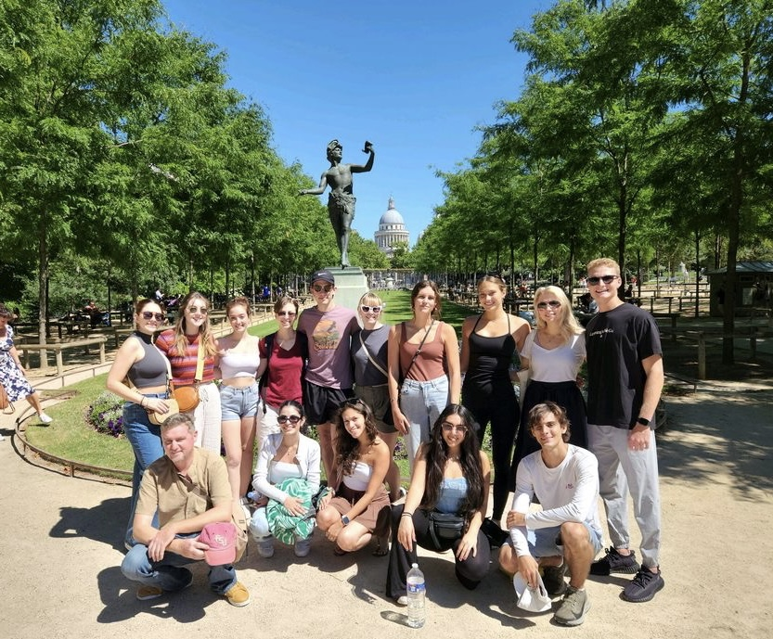
Image Courtesy: Tim Lomeli
Strike Out,
Writer: Mia Serrano-Salow
Editor: Noelle Knowlton
Tallahassee

